Event Name: Workshop on UV-Visible Spectrophotometer and PCR Thermal Cycler: Hands-On Training”
Event Date: 26th November, 2022
Number of Participants in such activities: 45
Event Venue/Time: Central Instrumentation Facility, Lab no 311, Block 5/ 10:00 am onwards
Organizing unit/ agency/ collaborating agency: University Institute of Sciences
Name of the scheme: Under the aegis of IQAC, SBBSU & IIC SBBSU

Activity Report
- With the heavenly blessings of Revered Sant Baba Dlawar Singh Ji (Brahm Ji), the benign endorsement of Sant Baba Sarwan Singh Ji (Chancellor, SBBSU), and under the able guidance of Prof. Dharamjit Singh Parmar (Vice-Chancellor, SBBSSU), under the aegis of IQAC & IIC SBBSU, University Institute of Sciences (Department of Physical Sciences , Department of Life Sciences, Allied Health Sciences & Agriculture Sciences) have successfully conducted a one Day workshop on “UV-Visible Spectrophotometer and PCR Thermal Cycler: Hands-On Training” on 26th November, 2022.
- Resource person for this workshop were:
  - Dr. Shweta Singh, Dean UIS, Associate Professor (Microbiology), SBBSU
  - Dr Nisha Sharma, Associate Professor (Chemistry), SBBSU
- Dr. Shweta Singh, expert for the workshop is Associate Professor (Microbiology) in the Department of Life Sciences, Allied Health Sciences & Agriculture Sciences, SBBSU. She has more than 9 year teaching and research experience. Her area of research included: Clinical Bacteriology, virology and molecular biology. She is currently guiding 3 PhD students and 5 M.Sc Project students in the field of clinical microbiology.
- 2nd Expert of the workshop was Dr. Nisha Sharma, Associate Professor (Chemistry), Department of Physical Sciences, Having more than 9 year of teaching & research experience. Main research interests includes: Biodegradation strategies for plastics, Functionalization of natural and synthetic polymeric systems, Drug delivery systems & nanocomposite formulations, She has supervised 1 PhD and 1 MPhil and 13 M.Sc Project students, 4 PhD students are working under her supervision.
Dr Sharma is a reviewer for various peer reviewed Journals and is Life Member of Asian Polymer Association; Membership no. L-641

- The workshop was designed with the intention to provide hands on training of two basic instruments of research: Double beam UV-VIS spectrophotometer and Thermocycler (PCR) for faculty and research students and master students of different disciplines.
- Workshop was inaugurated by Dr Mithu Maiti Jana, workshop convener and has provide the significance and applicability of such workshop. She highlighted the various prospective of instrumental techniques.
- There were more than 40 participants in this workshop, all have participated enthusiastically. Students, faculty and research scholars from various disciplines of science and technology have participated in this workshop. All sessions were highly informative.
- Workshop experts has provided a concrete knowledge about instrumentation, working and different applications of UV VIS spectrophotometer and PCR thermocycler in the field of physical and life sciences, medicines, pharmaceutical sector, agriculture sciences as well as in material characterizations.
- Experts have elaborated different components of these instruments and step wise significance of each component for analysis. Expert have provided detailed demonstration, how to analyze given sample and how to interpret the results afterward for the participants. Faculty and students have also performed experiment under the supervision of experts to provide them hands on training.
- There was demonstration and question/answer session and thorough discussion on instrumentation.
- Resource persons have explained recent applications of UV-Visible Spectrophotometer and PCR Thermal Cycler in biomedical, pharmaceutical, environmental analysis sectors.
- This workshop was full of knowledge and a guiding track for young researchers and has provided hands on training to each aspirants.
- Conveners of the workshop have paid vote of thanks to all the delegates and participants and paid gratitude to the university authorities for providing their support in organizing the workshop.
- There is no registration fee for the workshop. E-Certificates have been issued to all the participants for the successful participation and submission of the Feedback form of the Workshop (Feedback form provided at the end of the event).
Glimpse of the activity:
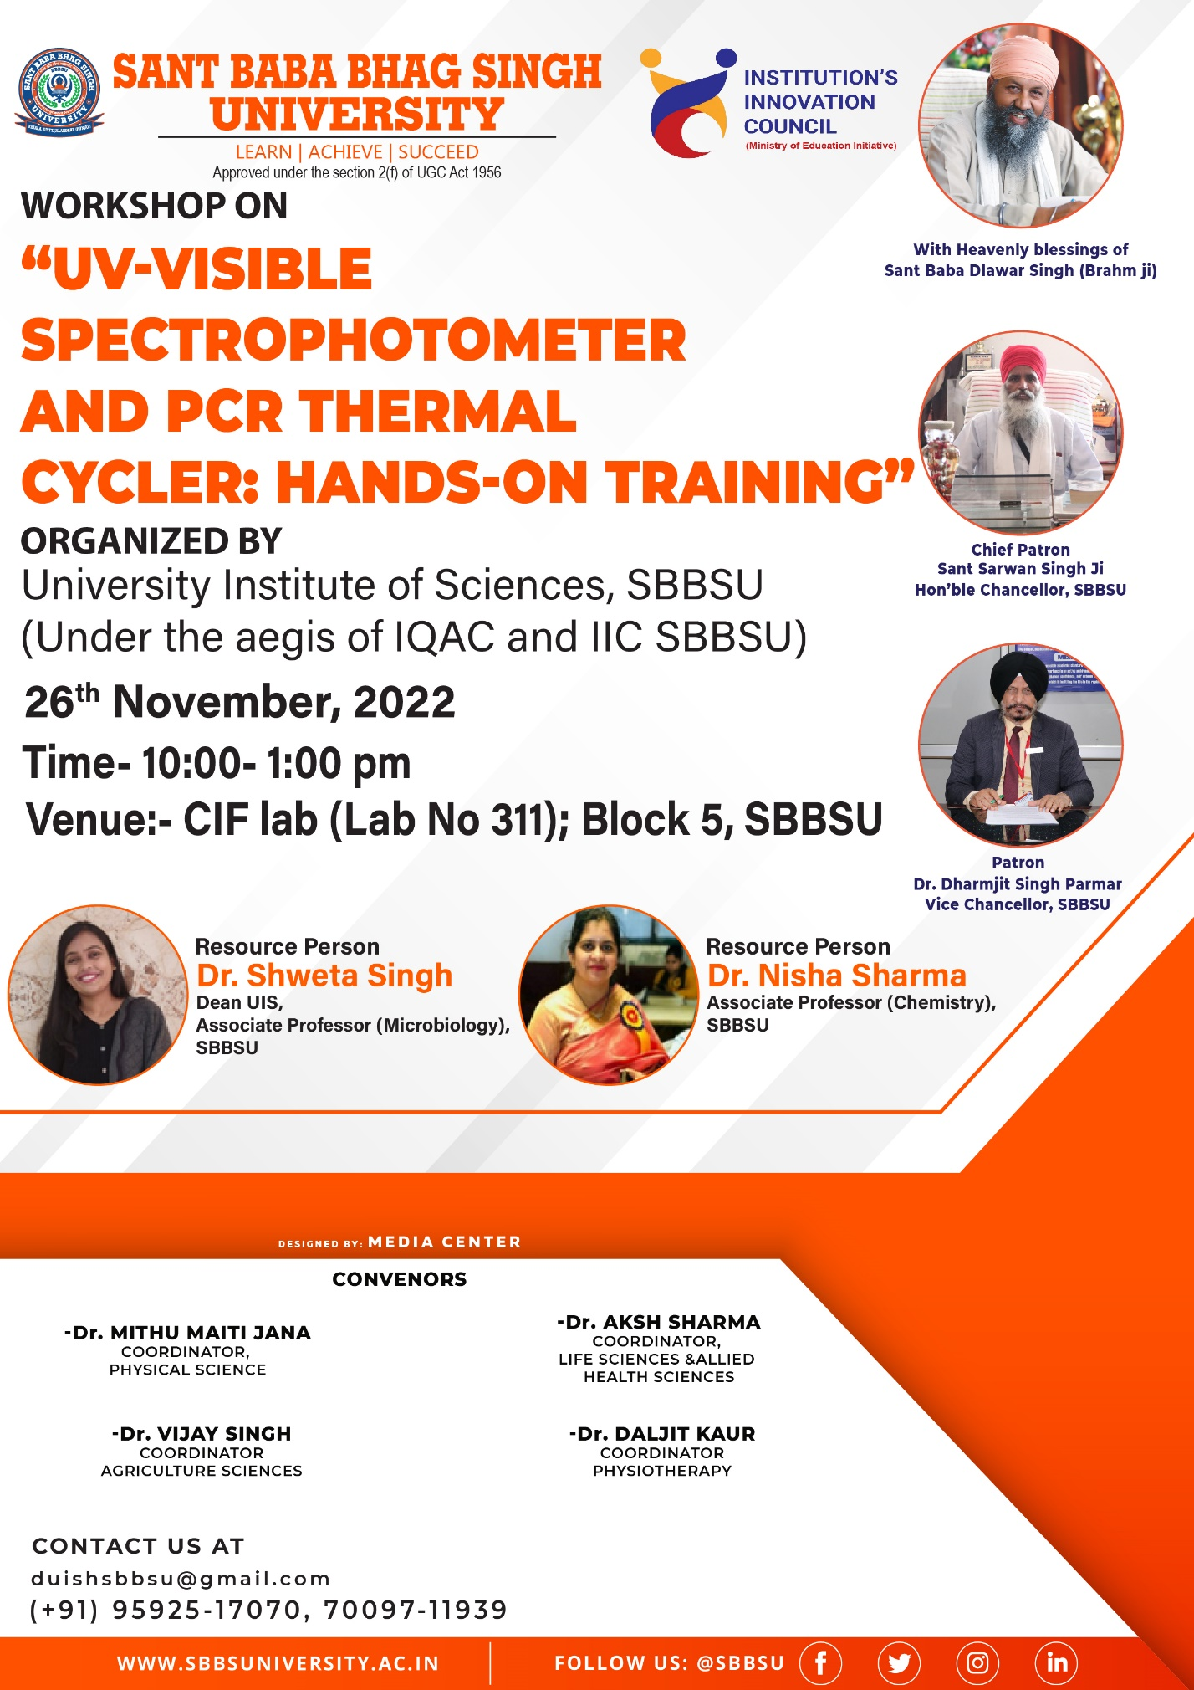

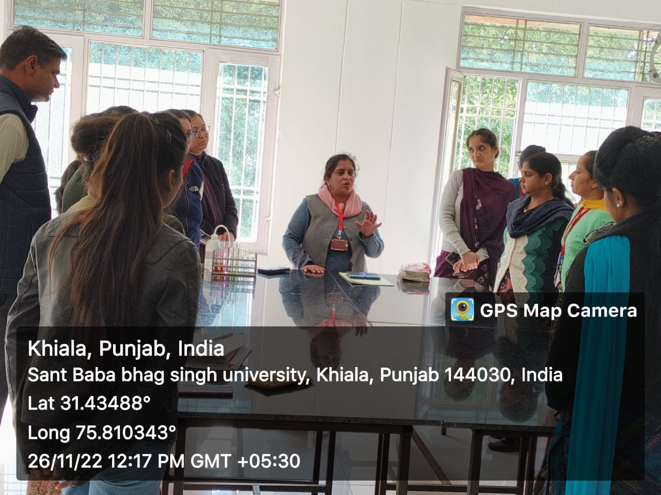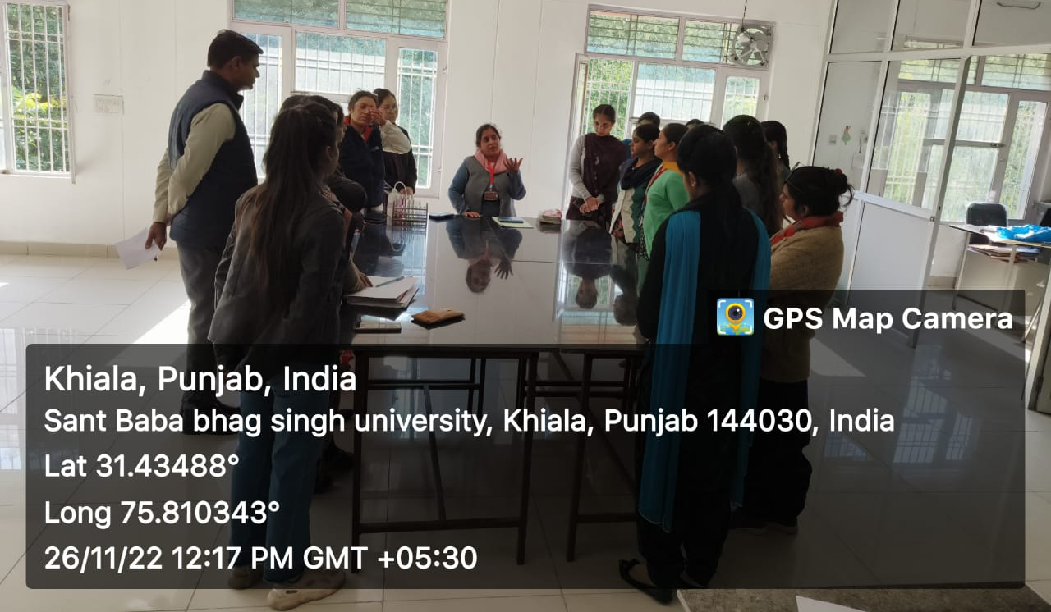
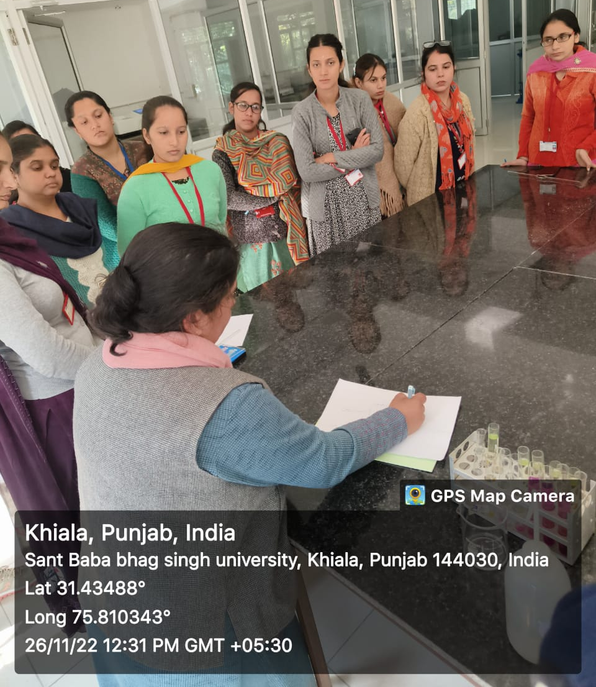
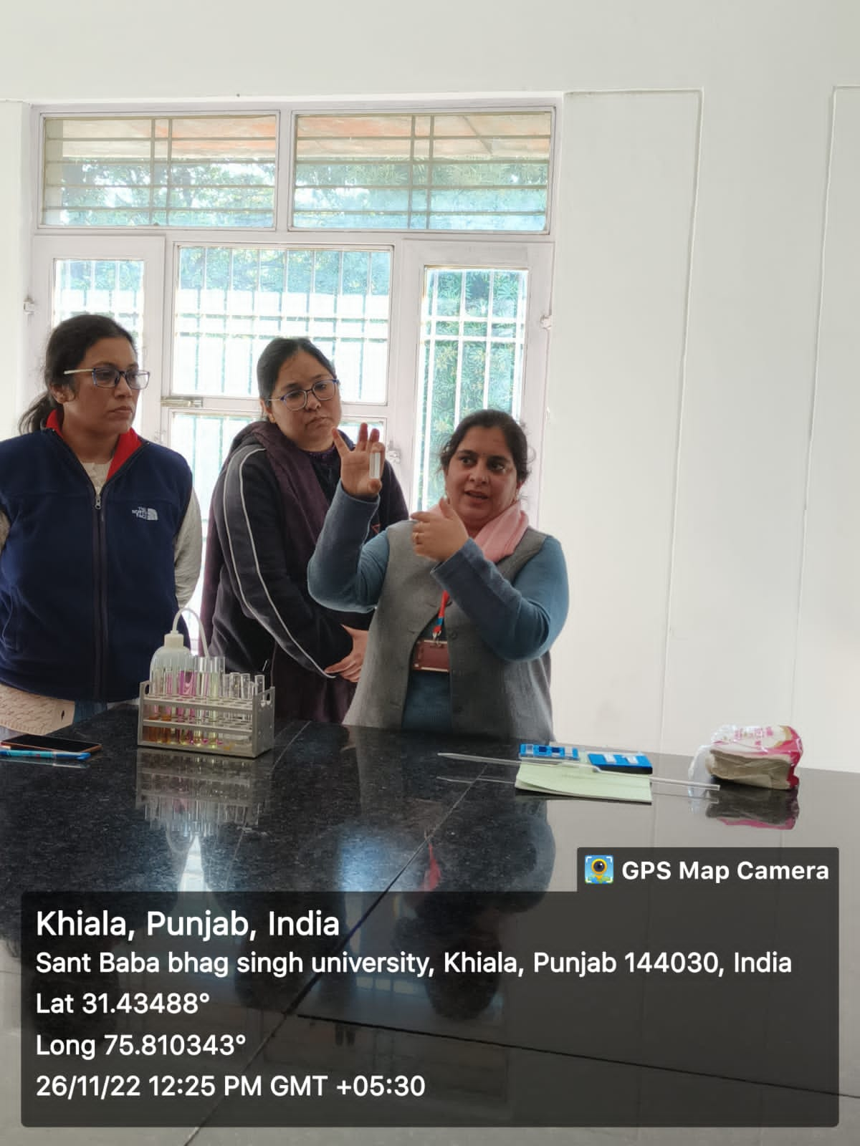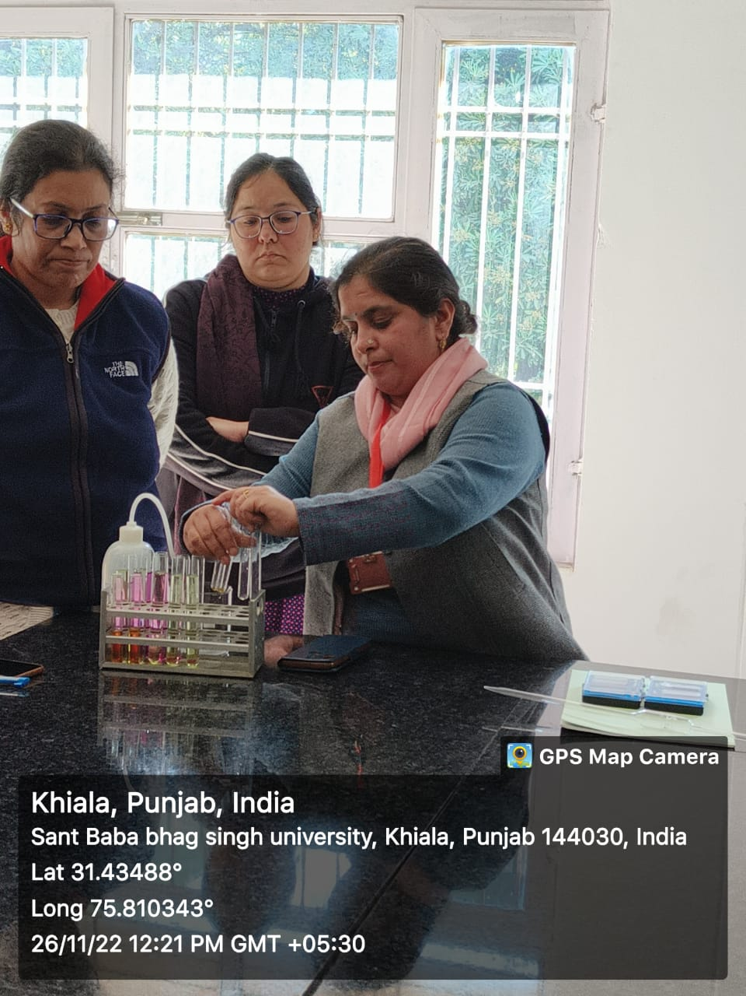
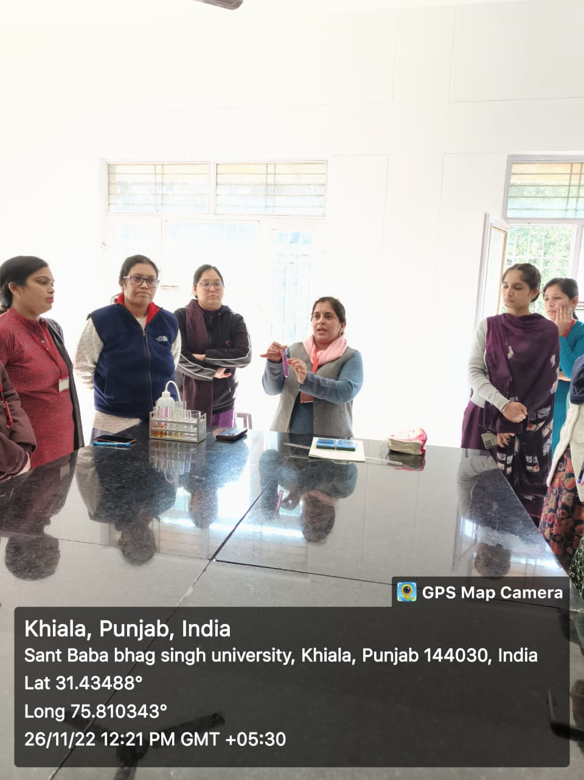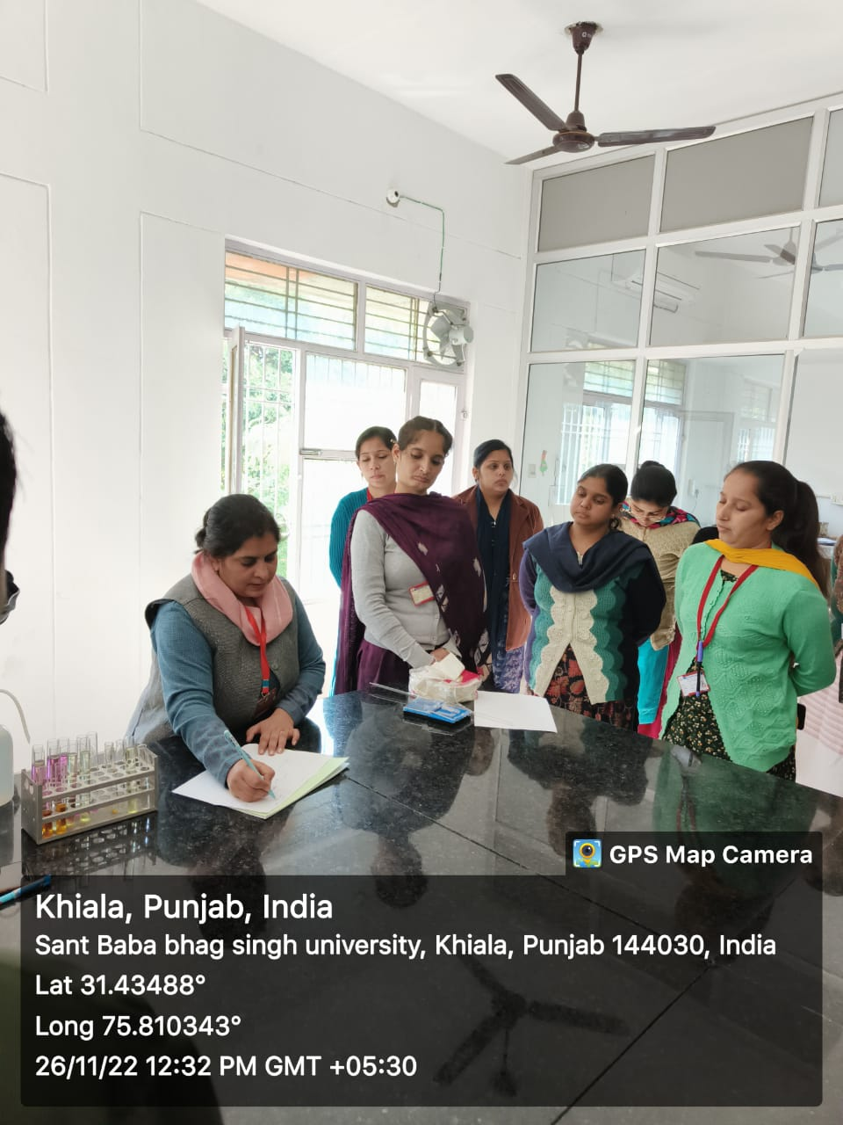
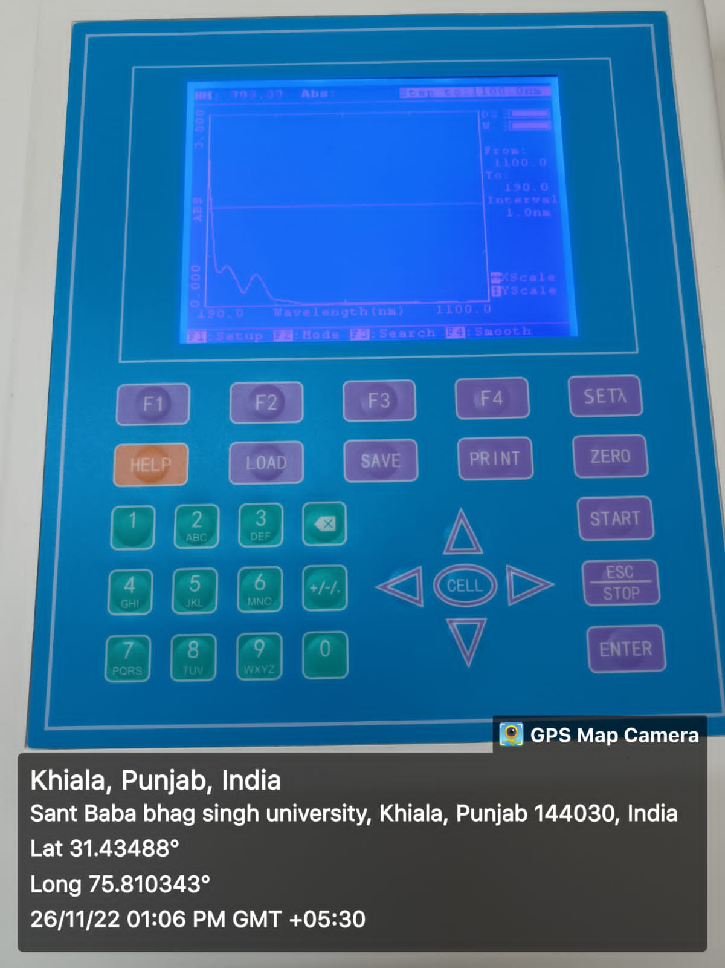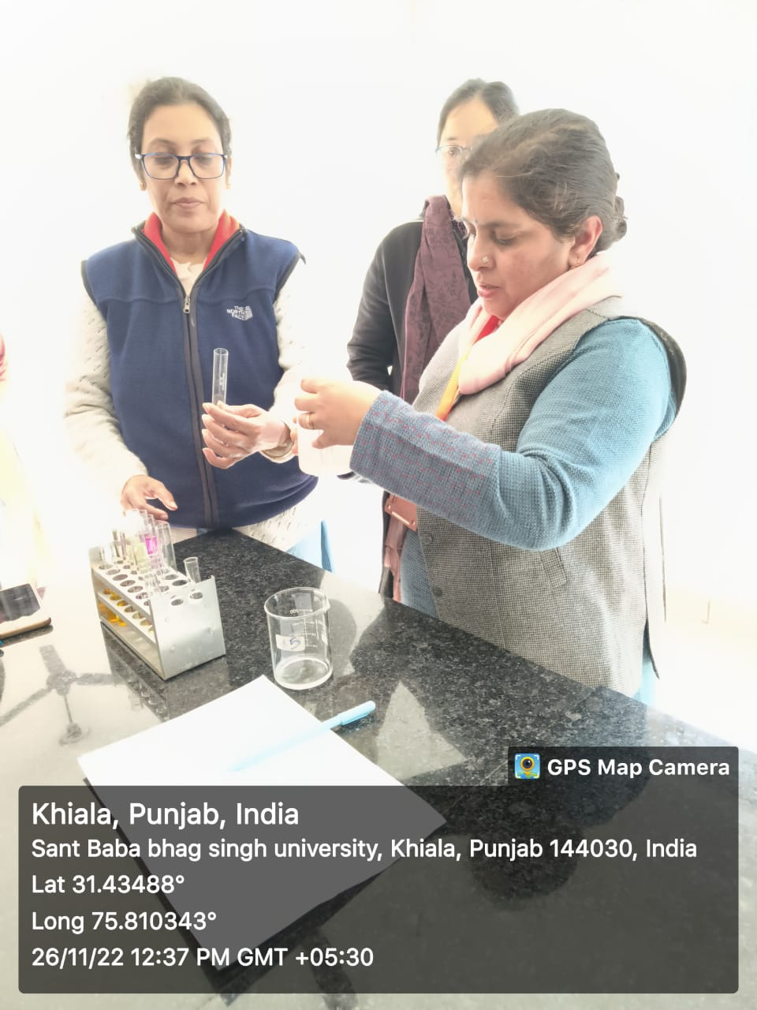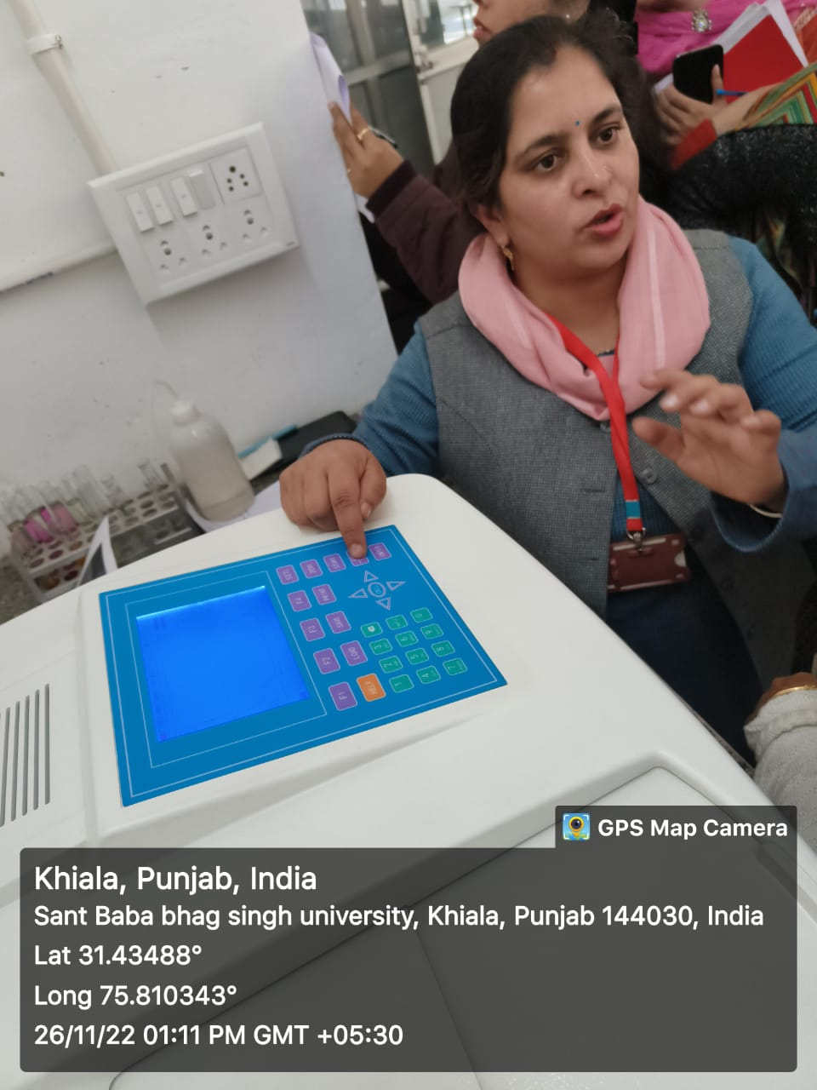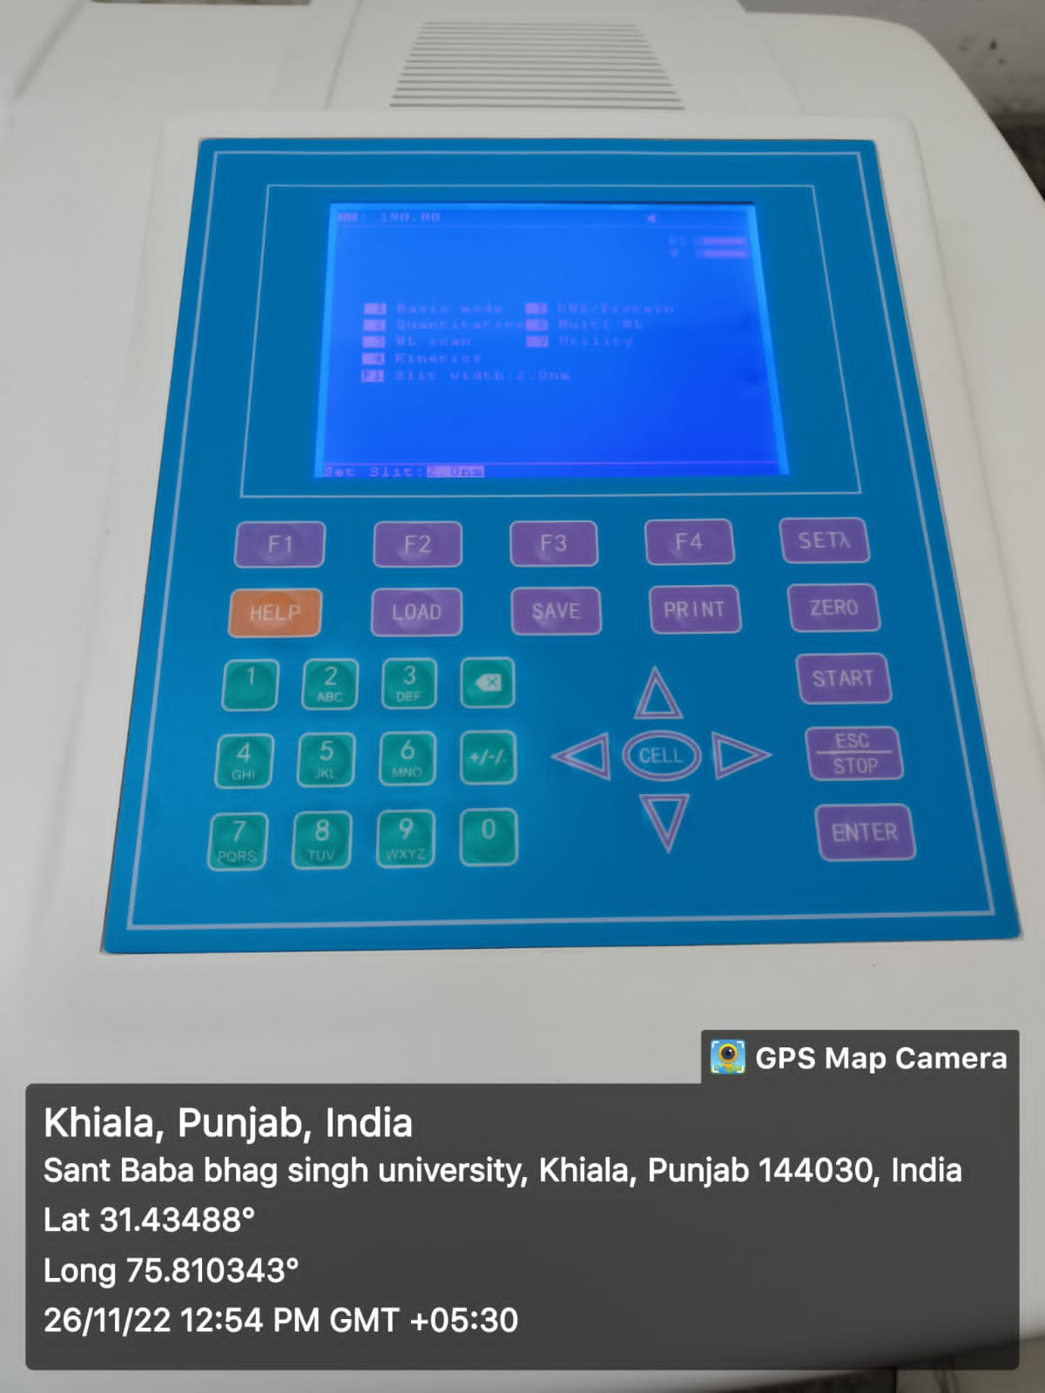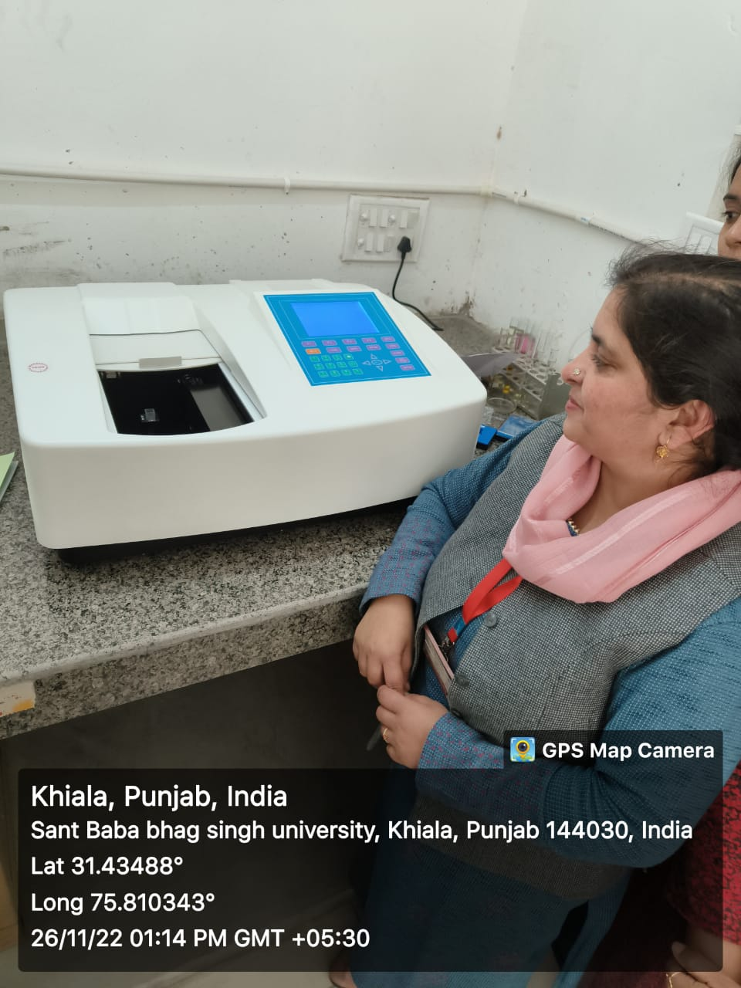
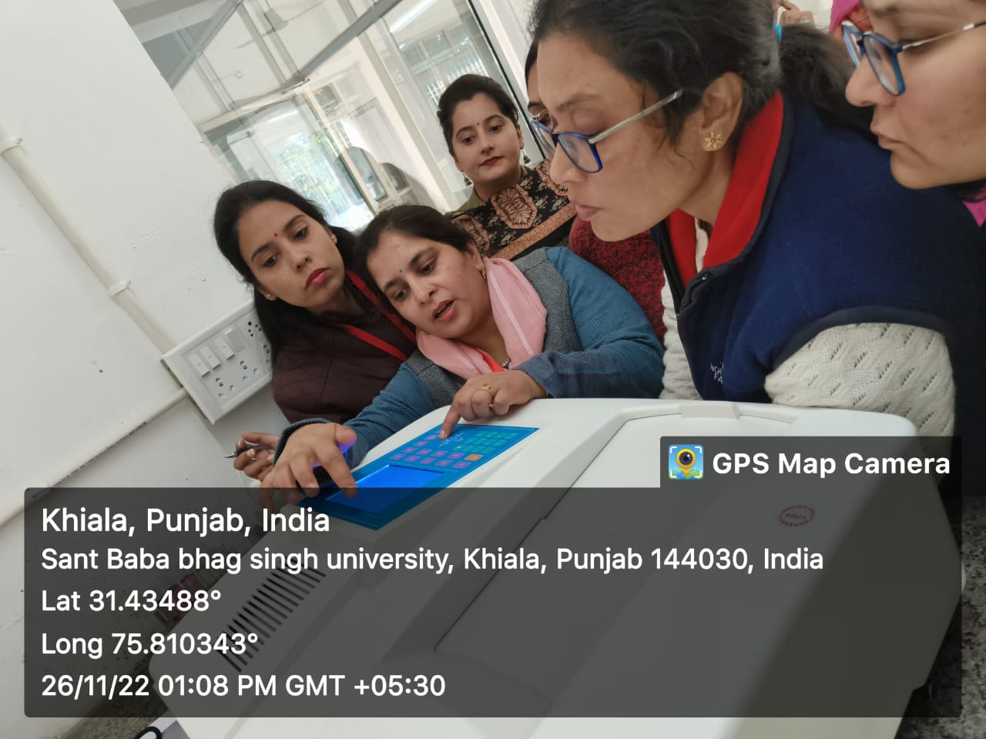
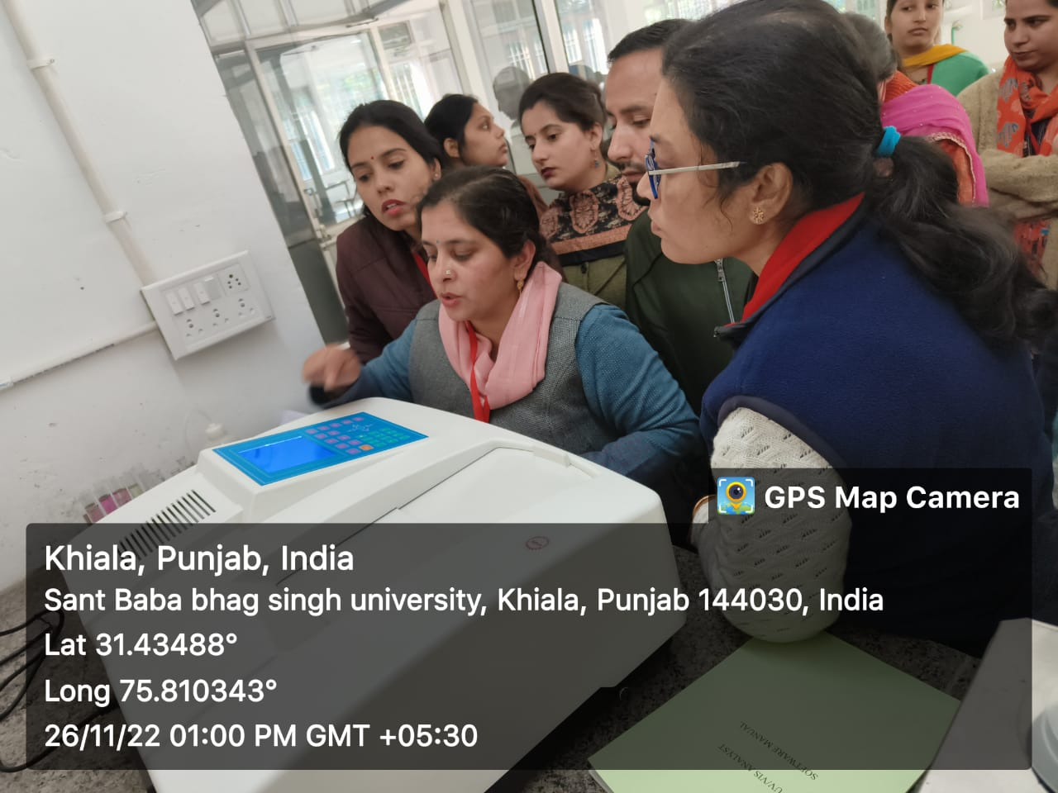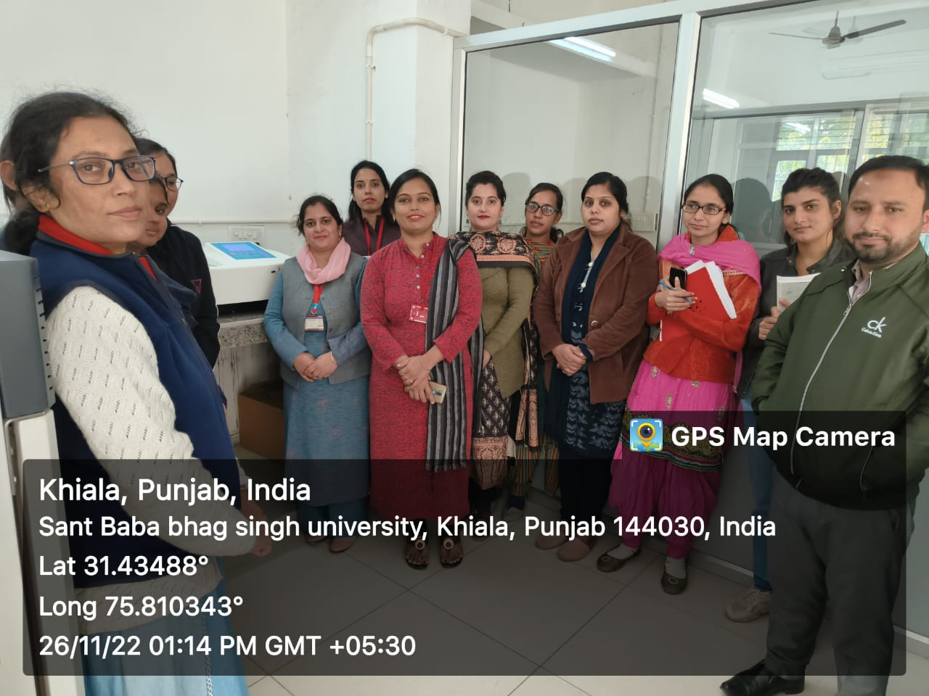
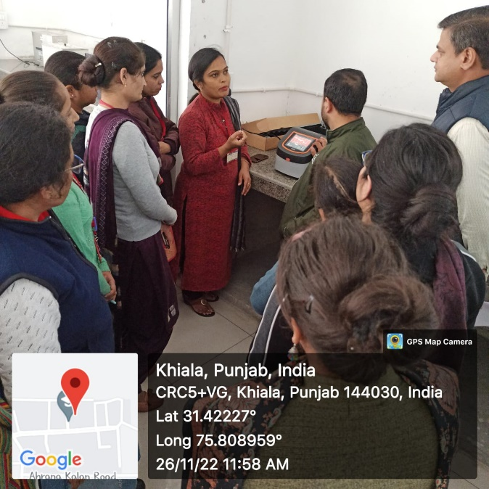
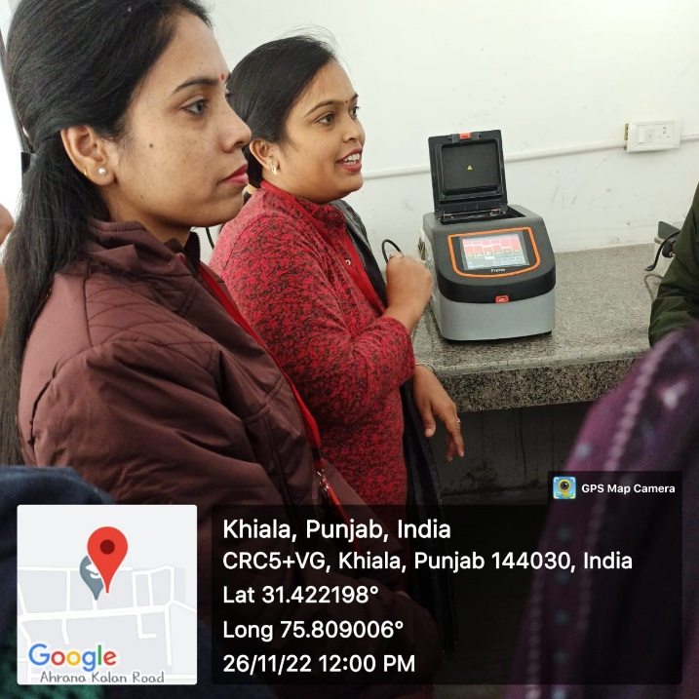
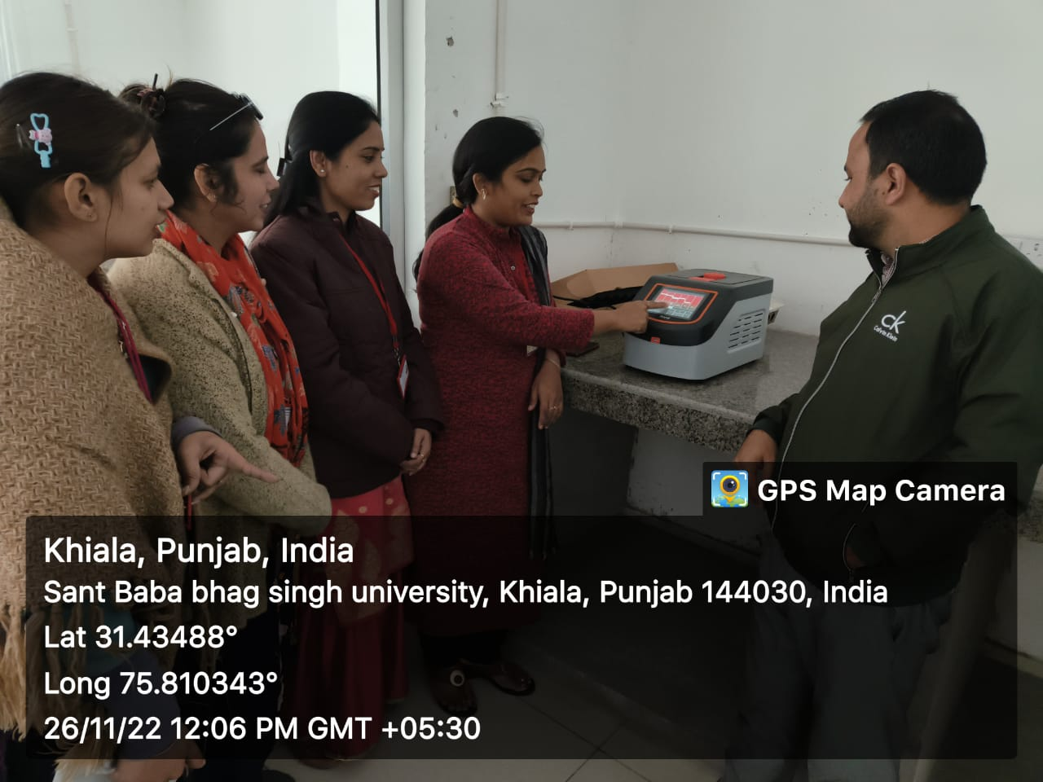
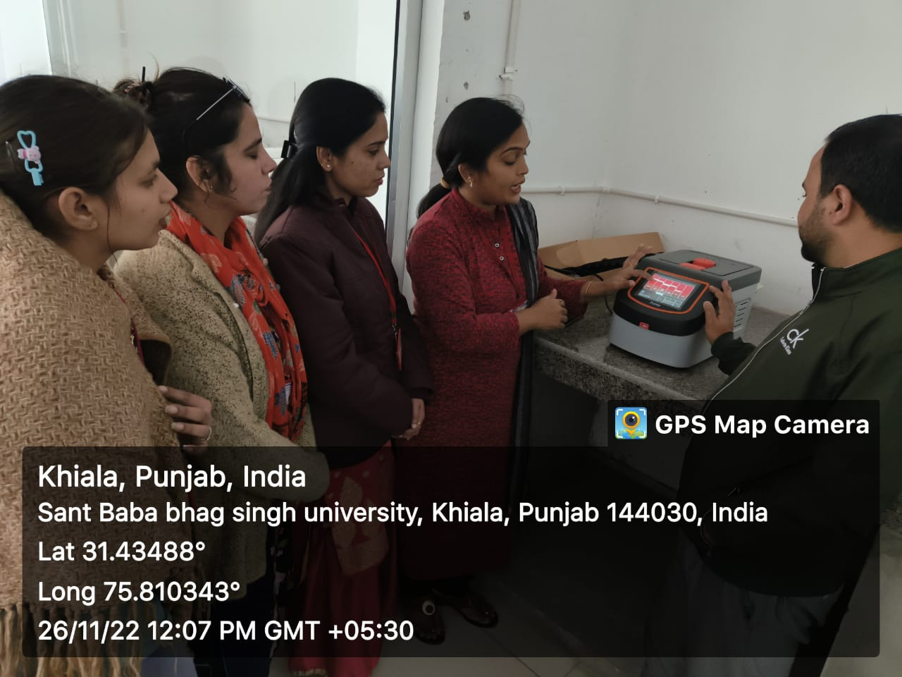
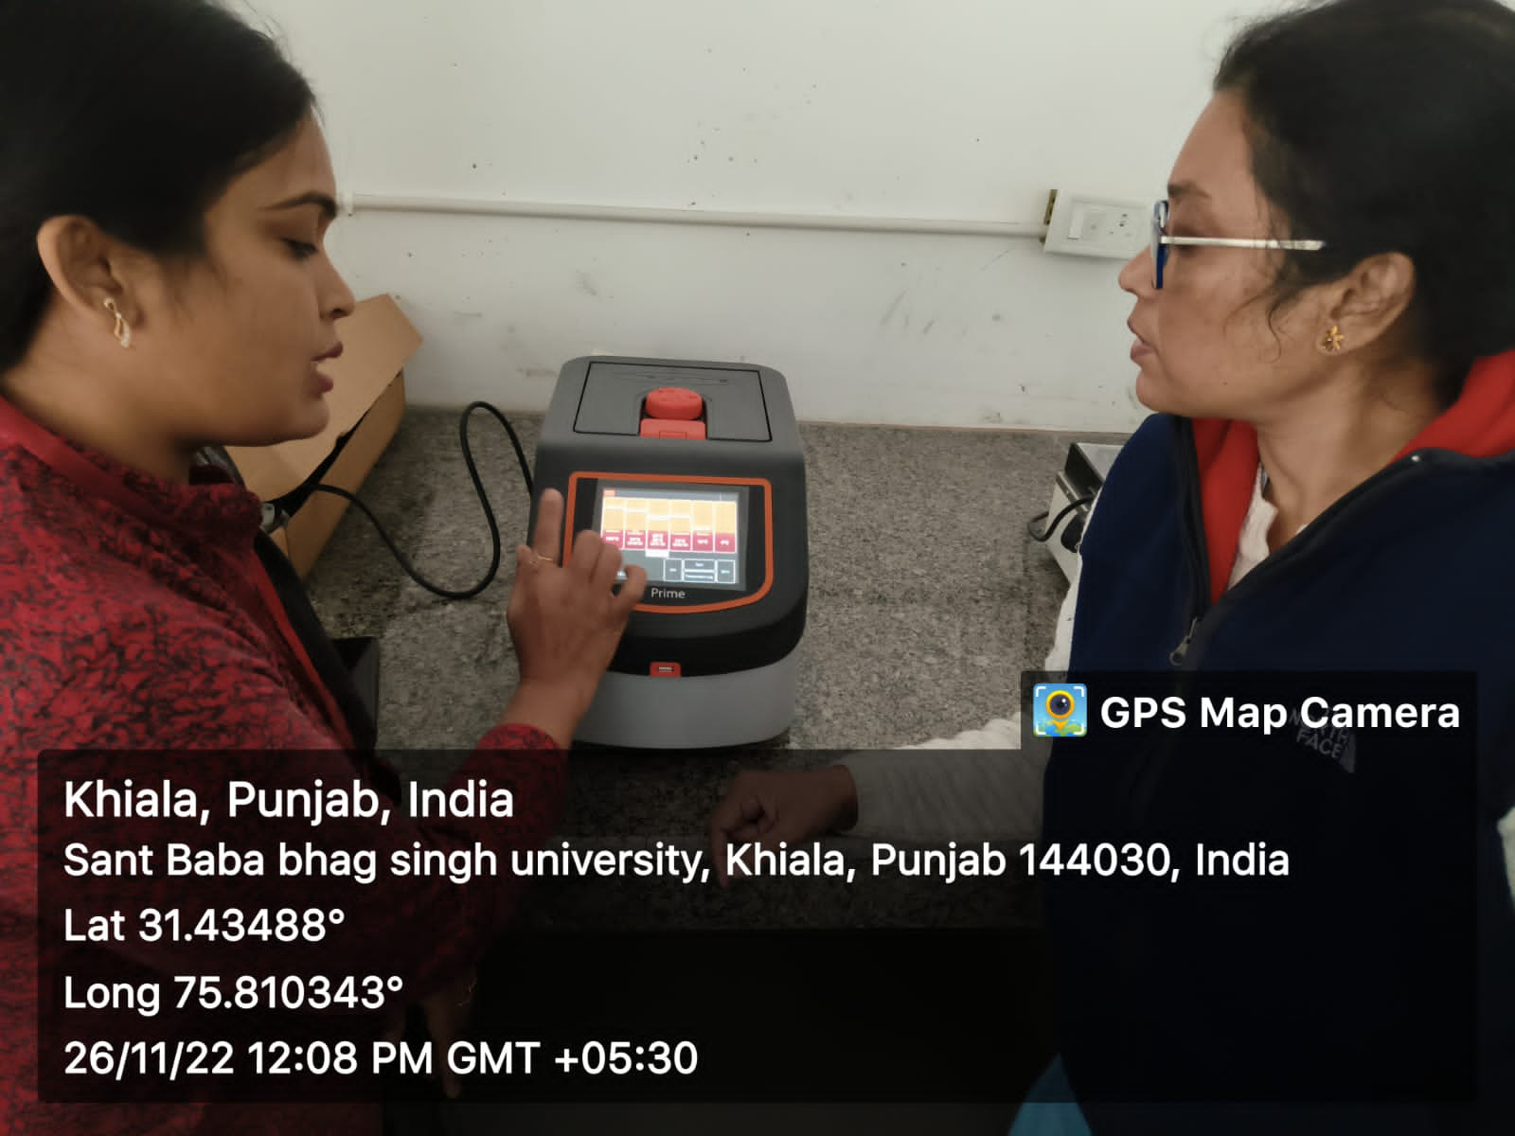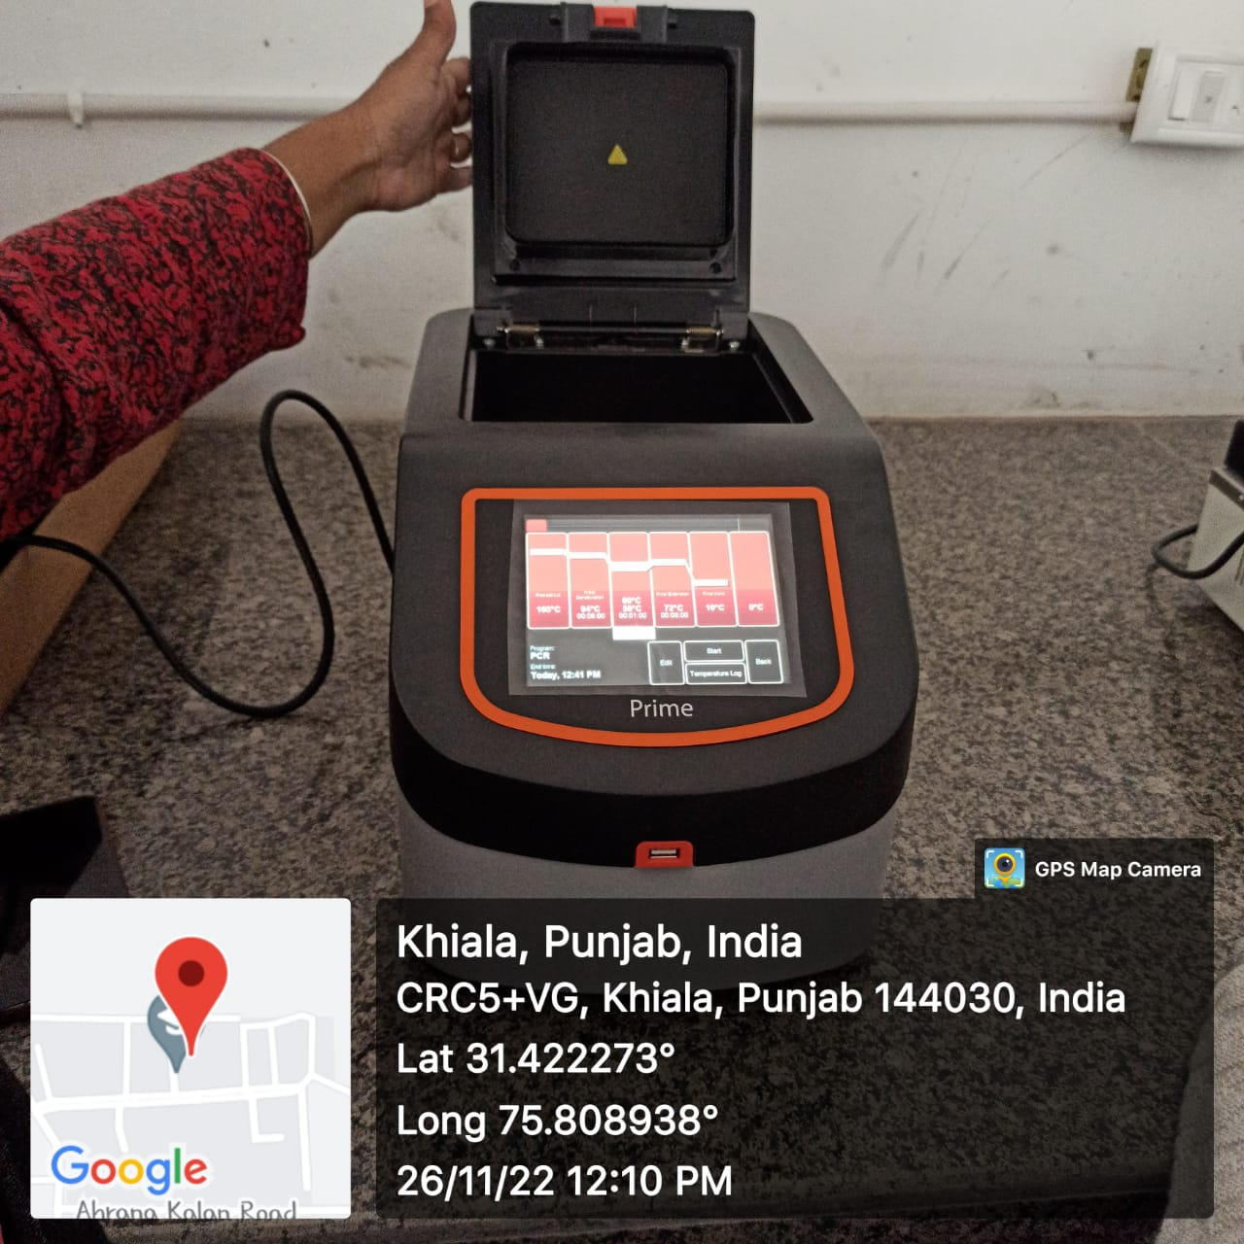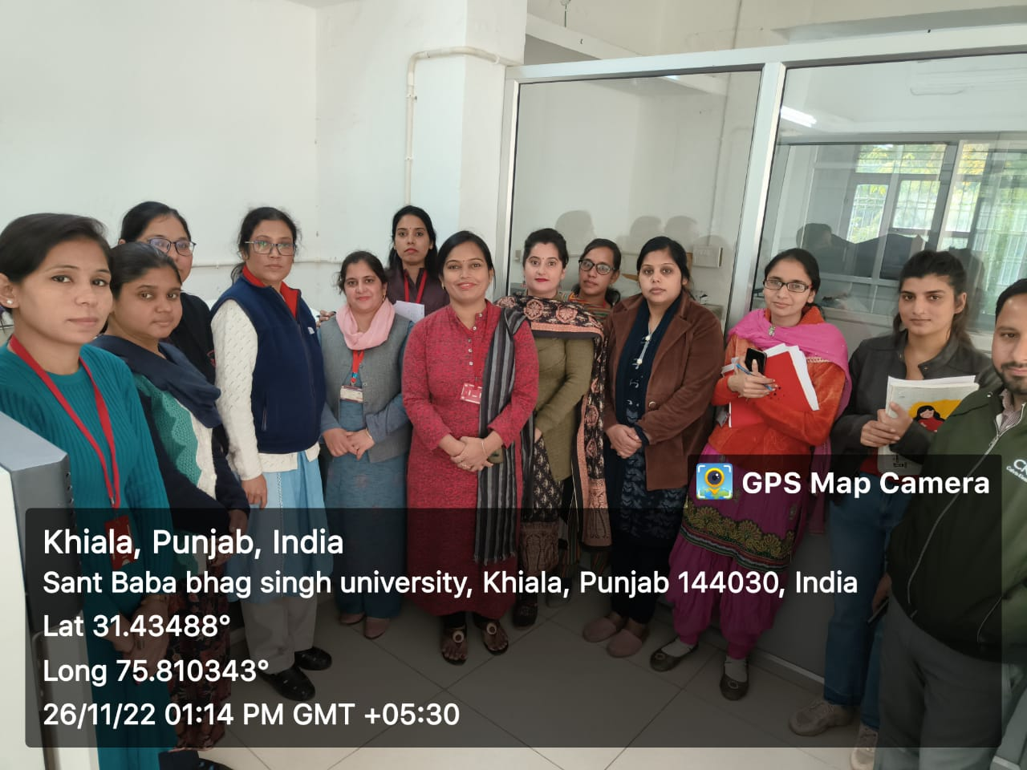

Convener

